Characteristics of Life

Biology is the study of living things. In this activity, you will learn about the characteristics that distinguish living things from non-living things. What characteristics are shared by all types of living things, including bacteria, mushrooms, plants and you?

1. To begin, write down what you think are the characteristics of living things. How can you tell whether something is a living thing or a non-living thing?

Next, you will view two videos, both entitled “Characteristics of Life”. The first video is simpler and provides a good introduction. This video is available at https://www.youtube.com/watch?v=0NnFhY_STFQ.

2. In this table, name and give examples of as many characteristics of life as you can remember from this video.

The second video provides more information about the characteristics of life and introduces some problems that biologists encounter as they try to decide what is living and what is non-living. This video is available at https://www.youtube.com/watch?v=cQPVXrV0GNA.

3. After you watch this video, complete the table in question 2.

4a. Describe two examples of non-living things that have one or more of these characteristics of life.

4b. If some non-living things have some of the characteristics of life, how can we distinguish these non-living things from living things?
5. Each figure in this question illustrates one or more of the characteristics of life that you have learned about. For each characteristic of life, find a figure that illustrates it and write a sentence or two that explains how the figure illustrates this characteristic of life.

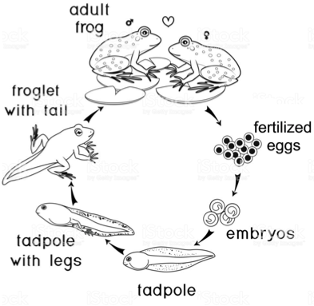
-----------------------------------------------------------------------------------------------------------------------------
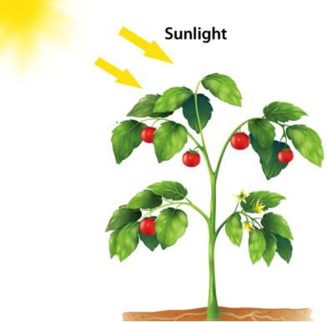
----------------------------------------------------------------------------------------------------------------------------
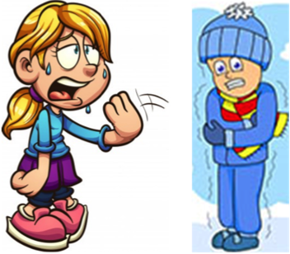

(Question 5 is continued on the next page.)
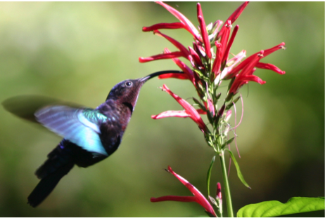
----------------------------------------------------------------------------------------------------------------------------
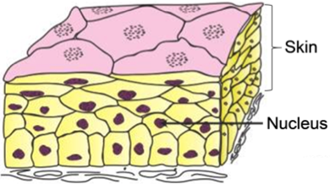
This figure shows a highly magnified view
of a cross-section of human skin.
----------------------------------------------------------------------------------------------------------------------------

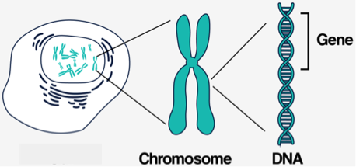
Some biologists include a “universal genetic code” as an additional characteristic of life. In all living things, DNA is the genetic material, and DNA uses the same code to give the instructions for making each organism’s proteins.

Some living things lack one or two of the characteristics of life. A mule is the offspring of a female horse and a male donkey. Mules cannot reproduce and, therefore, mules have not undergone evolutionary adaptation. However, mules have all the other characteristics of life, and they are universally accepted as living.

Viruses lack many of the characteristics of life. Viruses don’t maintain homeostasis. They don’t have energy metabolism or cellular organization. They don’t grow and develop.

6a. Which characteristics of life are observed in viruses? What are some differences in how these characteristics of life are observed in viruses vs. bacteria, plants and animals? (If needed, review the last part of the second video on page 1.)

6b. What do you conclude concerning whether viruses are alive? Is there a clear-cut distinction between living things and non-living things?

By Dr. Ingrid Waldron, Department of Biology, University of Pennsylvania © 2022. This Student Handout and Teacher Notes with instructional suggestions and biology background are available at https://serendipstudio.org/exchange/bioactivities/lifecharacteristics.

